**POLLEN'S PROFILING: AUTOMATED CLASSIFICATION OF POLLEN GRAINS**

**1.Introduction:**

This project addresses the growing need for a reliable and automated solution to the classification of pollen grains from microscopic images. By leveraging the capabilities of machine learning, it aims to streamline the analysis process, reduce dependence on manual expertise, and minimize subjectivity in interpretation.

Through the development and evaluation of a classification pipeline centered around image preprocessing, feature extraction, and Support Vector Machine (SVM) modeling the system aspires to improve both efficiency and accuracy in pollen identification workflows. It also provides a foundation for scaling the approach to accommodate additional pollen species, contributing to advancements in palynology and related fields.

* **Project Overview:**

This project presents an end-to-end framework for the automated classification of pollen grains using image-based machine learning. It begins with the collection and preprocessing of microscopic pollen images, ensuring uniformity in scale, contrast, and clarity. These images are then processed to extract meaningful features that capture the unique morphological traits of each pollen type.

A Support Vector Machine (SVM) classifier is employed to distinguish between various pollen categories, trained and validated on a curated dataset. The modular pipeline emphasizes reproducibility, enabling future extensions such as incorporating additional species or switching to deep learning architectures.

Designed to reduce manual workload and improve consistency in classification tasks, this system highlights the potential of intelligent automation in palynological research.

* **Purpose:**

The primary intent of this project is to develop an automated system that can classify pollen grains with high accuracy, addressing the limitations of traditional manual identification techniques. By applying machine learning to microscopic image data, the system aims to eliminate subjectivity, reduce analysis time, and promote consistency in classification outcomes.

This initiative serves not only to modernize palynological workflows but also to lay the groundwork for future innovations—such as integrating additional pollen varieties, exploring deep learning models, or deploying the solution in real-world botanical and environmental applications.

Conventional pollen identification methods are labor-intensive and time-consuming. The use of AI/ML models enables real-time or rapid classification, significantly cutting down the analysis time and human effort involved in ecological, botanical, or forensic studies.

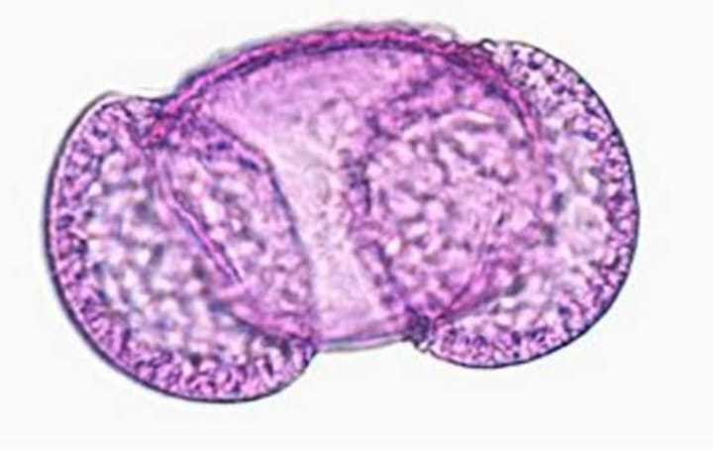

**2.Ideation Phase:**

* **Problem Statement**

Traditional pollen classification relies heavily on manual microscopic examination by trained palynologists. This process is slow, tedious, and requires significant human expertise, making it impractical for large-scale or real-time applications.Microscopic pollen grains often have minute morphological differences, making them difficult to distinguish by the human eye. This results in inconsistencies, subjective judgments, and classification errors, especially in complex or mixed samples.

There is a growing shortage of trained specialists in the field of palynology. This restricts the accessibility of pollen analysis in many regions and limits the scalability of biological and environmental research that depends on accurate pollen identification.Current systems are not well-suited for real-time detection of airborne pollen types, which is crucial for allergy forecasting, public health alerts, and environmental monitoring. Delays in identification can affect both research quality and public response.

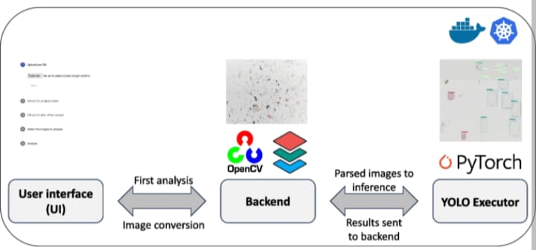

* **Empathy Map Canvas:**

In the context of automating pollen grain classification using artificial intelligence and machine learning, the empathy map helps us deeply understand the end-users—such as palynologists, environmental scientists, allergy specialists, and research students—who will benefit from the system. These users think and feel the pressure of performing accurate and timely pollen analysis, often burdened by the tediousness of manual identification and the fear of human error affecting research or diagnosis outcomes. They value precision, reliability, and scientific integrity, and they often feel frustrated by the limitations of traditional methods and the lack of access to trained professionals in some areas. They see a fragmented system of outdated tools, underdeveloped digital methods, and overwhelming volumes of microscopic data that are hard to process efficiently. They observe that while AI is transforming other areas of biology and healthcare, palynology is lagging behind due to a lack of scalable automation solutions.

They hear concerns from colleagues, academic circles, and stakeholders about the reproducibility of research, the rising demand for real-time environmental data, and the growing relevance of allergen tracking in public health. In their professional activities, users say and do things that reflect their desire for better tools: they advocate for innovation, collaborate on interdisciplinary projects, and often experiment with digital solutions despite limited technical expertise.

However, they experience several pains, such as the slow pace of manual work, classification inconsistency, lack of standardized data formats, and the steep learning curve for integrating machine learning into biological workflows. On the other hand, the envisioned AI/ML-based classification system offers considerable gains reducing workload, improving accuracy, accelerating data analysis, and democratizing access to high-quality palynological research.

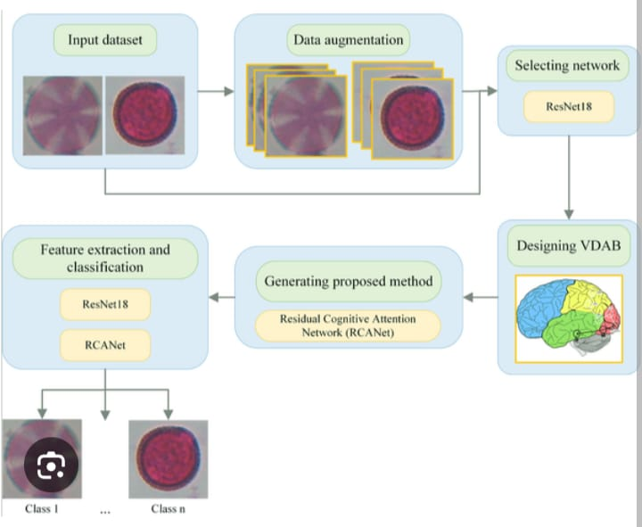

* **Brainstorming:**

In brainstorming the development of an AI/ML-based system for automated pollen grain classification, several innovative ideas and critical considerations emerge. First, the foundation of the project must be a well-curated, high-resolution image dataset of various pollen grains, annotated by experts and covering a wide range of plant species to ensure model generalizability.

Image preprocessing techniques like noise reduction, contrast enhancement, and segmentation will be essential for improving data quality. From a machine learning perspective, convolutional neural networks (CNNs) appear highly suitable due to their proven effectiveness in image classification tasks. Transfer learning using pre-trained models such as ResNet or Inception could provide a performance boost when data is limited. We must also brainstorm the integration of advanced data augmentation techniques to artificially expand the training dataset and improve robustness.

Another key area is the development of an intuitive user interface where scientists or technicians can upload pollen images and receive real-time classification results, along with confidence scores and potential species matches. There could be modules for comparing new findings with historical records for ecological trend analysis.

Cloud-based deployment might be explored for scalability and remote access. Further, we should consider collaboration with environmental and medical institutions for real-world testing, especially in allergy prediction and air quality monitoring. Ethical concerns, such as data privacy and misclassification consequences, must be addressed through validation pipelines and transparent AI explainability tools like Grad-CAM to visualize how the model makes decisions.

Lastly, future ideas could include automating slide scanning using robotic microscopes and integrating geolocation tagging to map pollen dispersal trends in real time, opening doors to climate research, precision agriculture, and biodiversity conservation.

1. **Requirement Analysis:**

* **Customer Journey map:**

In the journey of leveraging artificial intelligence and machine learning for pollen grain classification, the customer experience unfolds through multiple stages—each addressing a specific need while offering technological empowerment. The journey begins at the Awareness stage, where environmental researchers, agricultural scientists, healthcare professionals, and climate monitoring agencies recognize the critical need for accurate and timely identification of pollen grains to assess allergies, study biodiversity, and forecast ecological patterns. They often struggle with manual microscopic analysis, which is time-consuming, error-prone, and requires expert-level knowledge. As they transition to the Consideration stage, they explore AI/ML-based solutions that promise high accuracy, faster classification, and scalability. At this point, users evaluate platforms, tools, and systems capable of processing large datasets using image recognition and deep learning models.

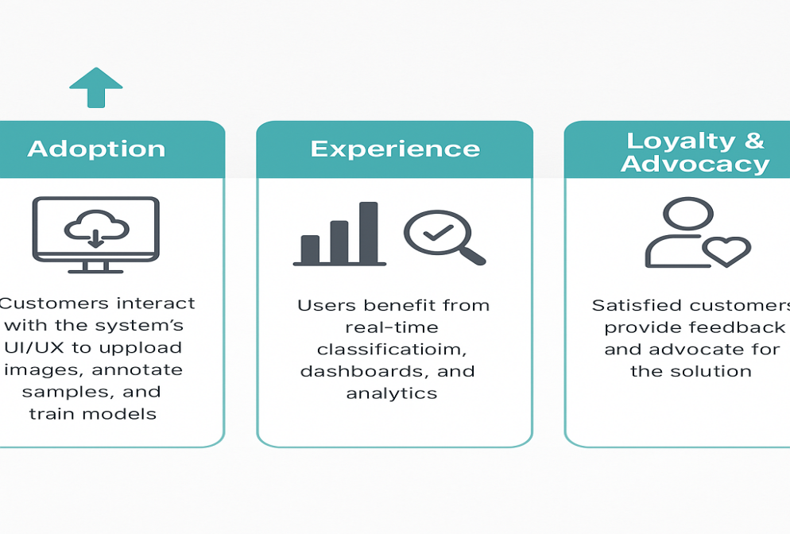During the Adoption phase, customers interact with the system’s UI/UX to upload microscope slide images, annotate samples, and train models, observing how convolutional neural networks (CNNs) and feature extraction techniques enhance precision in classification. In the Experience stage, users benefit from real-time classification, visual dashboards, and analytics that enable them to monitor pollen spread or ecological impacts effectively. Throughout this phase, the ease of integration with lab equipment, cloud accessibility, and technical support becomes crucial. Finally, in the Loyalty and Advocacy stage, satisfied customers provide feedback, suggest improvements, and advocate for the solution in academic or professional circles, contributing annotated data that further trains and refines the model. This AI/ML-driven journey transforms traditional pollen classification into a smart, scalable, and user-centric process, making it indispensable for scientific and public **health communities.**

* **Solution Requirements:**
* To develop a robust AI/ML-based solution for the automated classification of pollen grains, several critical requirements must be fulfilled across hardware, software, algorithmic, and data dimensions.
* The foremost requirement is the availability of a high-quality, diverse, and annotated dataset of pollen grain images captured under different magnifications and lighting conditions using microscopic imaging. These datasets must include multiple pollen types with proper class labels to enable effective supervised learning.
* The solution must incorporate advanced image preprocessing techniques, including noise reduction, contrast enhancement, normalization, and segmentation to isolate pollen grains from background artifacts. For feature extraction and classification, deep learning models, particularly Convolutional Neural Networks (CNNs), are essential due to their proven performance in handling image-based classification tasks.
* These models need to be trained on GPU-enabled infrastructure to reduce training time and improve accuracy.
* The system must include data augmentation techniques such as rotation, scaling, and flipping to address class imbalance and improve model generalization. A scalable machine learning pipeline should be designed for continuous learning and improvement, allowing for retraining with new data and integration with real-time classification systems.
* Furthermore, the solution should feature a user-friendly graphical interface or dashboard that enables users to upload images, receive instant classification results, visualize model confidence scores, and generate analytical reports.
* Integration with cloud services can ensure remote access, data storage, and computational scalability. Lastly, ensuring interpretability of AI decisions through tools like Grad-CAM or SHAP, along with data security and compliance with scientific data-sharing standards, is essential for building user trust and ensuring adoption across research, agricultural, and environmental monitoring sectors.

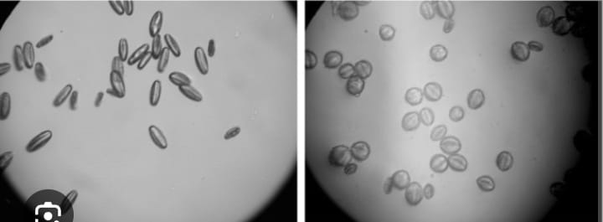

* **Data Flow Diagram**

The Data Flow Diagram illustrates the flow of information through the system and highlights how data moves between different components. It helps visualize the logical structure of the classification process.

**Level 0 (Context-Level DFD)**  
At the highest level, the system is viewed as a single process interacting with external entities:

* **Inputs**: Pollen grain microscopic images
* **Process**: Automated Classification System
* **Outputs**: Classification results (species name, confidence level)
* **External Entities**: User/Researcher, Image Database

**Level 1 (Detailed DFD)**  
This breaks down the system into major subprocesses:

1. **Image Acquisition** – Captures or uploads microscopic images
2. **Preprocessing** – Applies filters for noise removal, normalization, and enhancement
3. **Feature Extraction** – Extracts characteristics like shape, size, and texture
4. **Classification Module** – Uses trained ML or deep learning models to classify pollen grains
5. **Result Display** – Shows classification results with relevant metrics

**Data Stores**:

* **Image Database** – Stores acquired images
* **Trained Model Repository** – Contains ML/DL models used for classification
* **Result Archive** – Keeps history of classification outcome

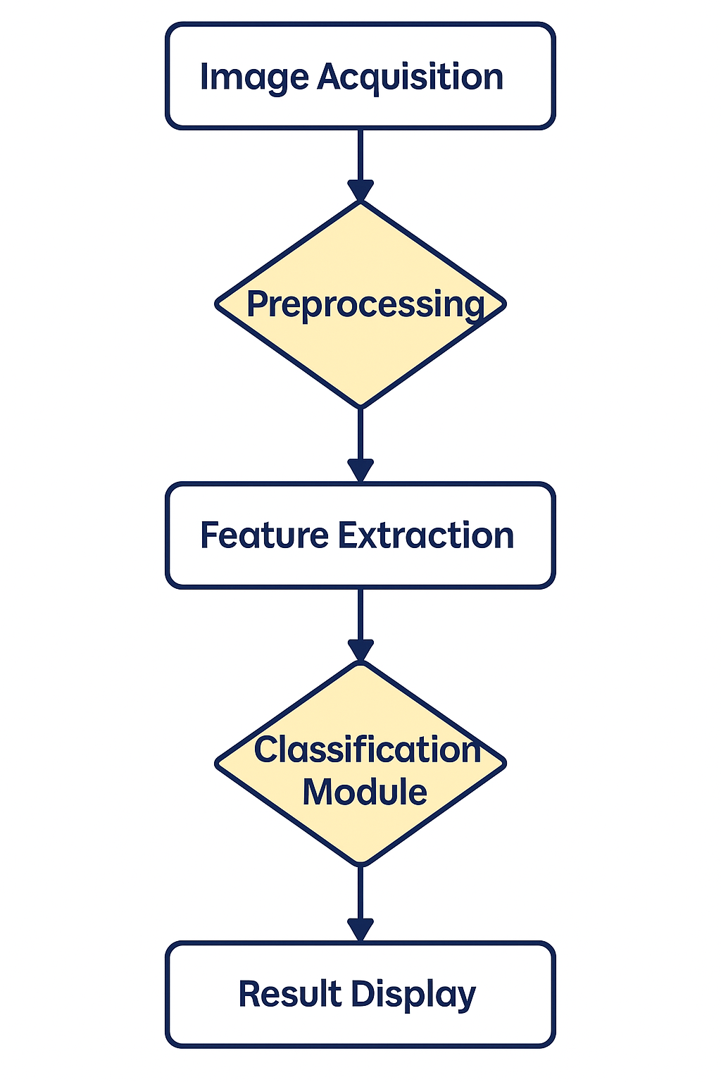

* **Technology Stack:**

The technology stack for implementing an AI/ML-based automated pollen grain classification system is a blend of cutting-edge tools, frameworks, and platforms across data acquisition, model development, and deployment layers. At the hardware level, high-resolution digital microscopes or slide scanners are used to capture detailed images of pollen grains, often supported by GPU-accelerated workstations or cloud-based compute services like NVIDIA GPUs on AWS, Google Cloud, or Azure for training deep learning models efficiently. The data layer involves using storage solutions like Amazon S3, Google Cloud Storage, or local databases (e.g., PostgreSQL, MongoDB) to store raw images, preprocessed datasets, metadata, and results. The preprocessing and model development layer relies heavily on programming languages like Python along with scientific libraries such as OpenCV for image preprocessing, NumPy and Pandas for data manipulation, and Matplotlib or Seaborn for visualizations. For building the machine learning pipeline, scikit-learn is used for traditional ML models, while TensorFlow, Keras, or PyTorch are essential for implementing and training Convolutional Neural Networks (CNNs) for image classification. For annotation of datasets, tools like LabelImg or CVAT can be used to create labeled datasets for supervised learning. To ensure efficient workflow management, Jupyter Notebooks or integrated development environments like VS Code or PyCharm are used during development. In the deployment layer, the trained models are packaged and deployed using Flask or FastAPI as lightweight REST APIs, which are then hosted using Docker containers on platforms like Heroku, AWS EC2, or Kubernetes clusters for scalability. The front-end interface or dashboard for users is built using React.js, HTML/CSS, or Dash/Streamlit, allowing users to upload images, view classification results, and interact with the system in real-time. For monitoring and versioning, tools like MLflow, DVC (Data Version Control), and TensorBoard are used to track model performance and dataset evolution. This comprehensive technology stack ensures high performance, scalability, and reliability in delivering an intelligent, automated pollen classification solution powered by artificial intelligence and machine learning.

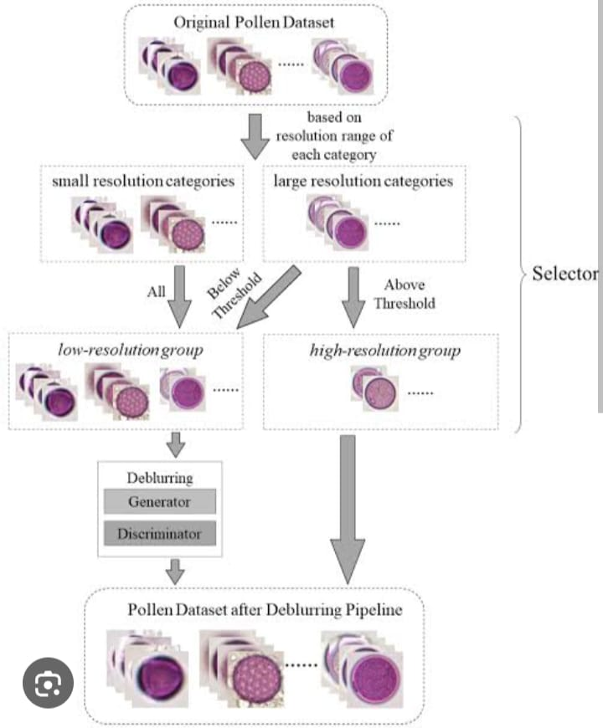

1. **Project Design:**

* **Problem Solution Fit:**
* The problem-solution fit for the pollen profiling and automated classification project using artificial intelligence and machine learning lies in addressing the inefficiencies, inaccuracies, and limitations of traditional pollen grain identification methods through an intelligent, data-driven approach.
* Traditionally, pollen classification is a labor-intensive and error-prone task performed manually by palynologists using microscopes, requiring significant expertise, time, and concentration.
* The manual nature of the process makes it highly susceptible to human error, low scalability, and impractical for large-scale environmental or agricultural monitoring.
* Moreover, there is a growing demand in fields such as allergy forecasting, climate change studies, and forensic palynology for rapid, accurate, and automated pollen analysis systems.
* This is where AI and ML offer a powerful solution by enabling automated image analysis, pattern recognition, and classification at scale. By training deep learning models such as Convolutional Neural Networks (CNNs) on annotated pollen images, the system can accurately identify and classify various pollen types based on visual features like shape, size, and texture often with higher consistency than human analysts.
* The integration of preprocessing, feature extraction, and real-time prediction into a unified workflow ensures that the system can handle large volumes of data with minimal human intervention.
* This automated pipeline not only reduces operational costs and time but also expands accessibility to pollen analysis in remote or resource-limited environments through cloud-based deployment. Additionally, the continuous learning capability of AI/ML models allows for ongoing improvement and adaptation to new pollen types or imaging conditions.
* Thus, the AI-powered solution directly addresses the core challenges of manual pollen classification and provides a scalable, accurate, and efficient alternative that perfectly fits the real-world problems faced by researchers, healthcare professionals, agriculturalists, and environmental agencies.

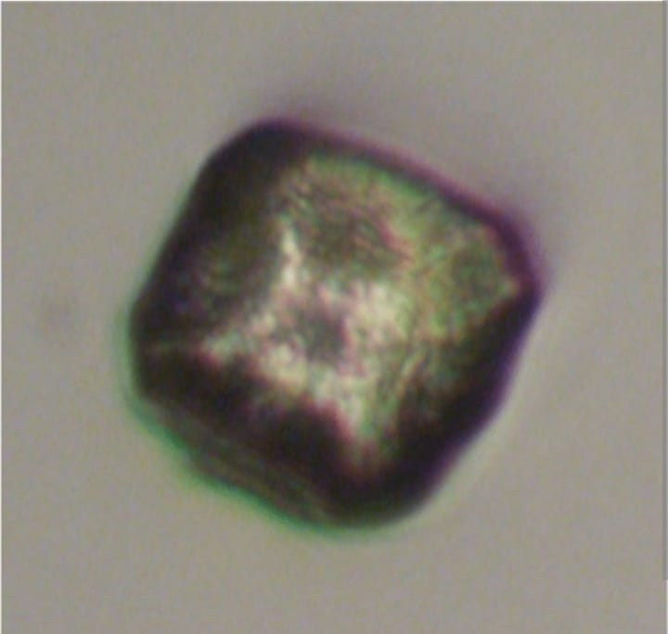

* **Proposed Solution:**
* The proposed solution for automated pollen grain classification using artificial intelligence and machine learning is a comprehensive, end-to-end system that leverages advanced image processing and deep learning techniques to accurately identify and classify various pollen types with minimal human intervention.
* At its core, the system begins with the acquisition of high-resolution microscopic images of pollen grains, which are then passed through an image preprocessing pipeline that enhances clarity by removing noise, adjusting contrast, and segmenting individual pollen grains from the background.
* These refined images are fed into a deep learning model specifically a Convolutional Neural Network (CNN)—which is trained on a diverse, labeled dataset of pollen images to learn distinguishing features such as shape, texture, size, and surface patterns.
* The CNN architecture is optimized using techniques like data augmentation, transfer learning, and hyperparameter tuning to ensure high accuracy and generalization across different pollen classes.
* Once trained, the model is integrated into a user-friendly platform that allows researchers, environmental analysts, or agricultural professionals to upload new pollen images and receive instant classification results along with confidence scores.
* The backend supports continuous learning by incorporating user feedback and newly labeled data to retrain and update the model periodically, improving its performance over time.
* The solution also includes a visual analytics dashboard that displays classification outcomes, pollen distribution trends, and historical data for research and reporting purposes.
* Deployed on cloud infrastructure, the system ensures accessibility, scalability, and real-time performance, making it suitable for widespread use in laboratories, research institutions, weather monitoring agencies, and healthcare environments.
* 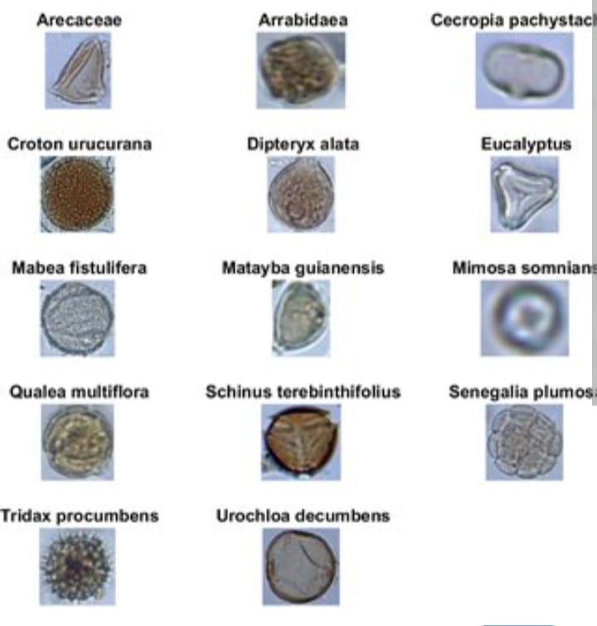By automating a traditionally manual and expertise-driven process, this AI/ML-powered solution not only increases speed and accuracy but also democratizes access to pollen analysis, helping address challenges in allergy prediction, climate studies, and biodiversity research.
* **Solution Architecture:**

The solution architecture for the pollen profiling and automated classification of pollen grains using artificial intelligence and machine learning is a modular, scalable, and intelligent framework that seamlessly integrates data acquisition, preprocessing, model inference, user interaction, and continuous learning. At the foundation, the Data Acquisition Layer involves capturing high-resolution images of pollen grains using digital microscopes or slide scanners, which are then uploaded to a centralized system either through local storage or cloud-based services like AWS S3 or Google Cloud Storage.

These raw images are passed into the Image Preprocessing Layer, where operations such as resizing, noise removal, normalization, and segmentation are performed using libraries like OpenCV and scikit-image to isolate pollen grains and standardize input quality. The processed images are then fed into the AI/ML Model Layer, which houses a pre-trained and continuously updated Convolutional Neural Network.

(CNN) built using frameworks such as TensorFlow, Keras, or PyTorch.

This model is responsible for feature extraction and classification of pollen types based on learned visual patterns. The output, which includes predicted pollen classes and confidence scores, is then managed by the Inference and Results Layer, where results are interpreted and stored in databases such as PostgreSQL or MongoDB. A Web-Based Application Layer, developed using frameworks like Flask, FastAPI (backend), and React.js or Streamlit (frontend), provides a user interface through which users can upload images, receive instant classification feedback, view analytics, and download reports.

This interface connects with an Analytics and Visualization Layer, where dashboards display pollen classification trends, distribution maps, and historical comparisons using tools like Plotly, Dash, or Tableau.

For scalability and deployment, the entire system is containerized using Docker and orchestrated through Kubernetes or deployed on cloud platforms such as AWS EC2, Azure, or GCP.

The architecture also features a Model Management and Retraining Module, where feedback from users (e.g., corrections or new data inputs) is incorporated into a training pipeline powered by MLflow or DVC, enabling continual improvement of the model. Security layers ensure data privacy and compliance, while logging and monitoring tools such as Prometheus and Grafana oversee performance.

This holistic solution architecture provides a reliable, intelligent, and user-centered system capable of transforming traditional pollen grain classification through AI and ML innovation.

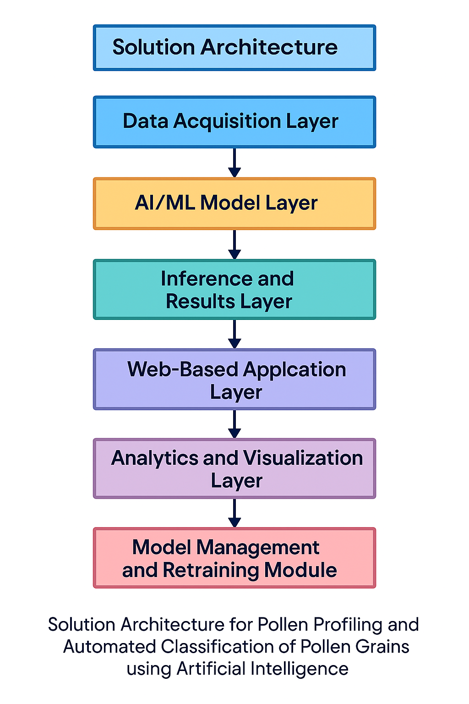

1. **Project Planning & Scheduling:**

* **Project Planning:**

The project planning for implementing an AI/ML-based pollen profiling and classification system in Google Colab follows a structured development and execution cycle to ensure effective outcomes and reproducibility. The first phase involves data preparation, where high-resolution microscopic images of pollen grains are collected, labeled, and organized into training, validation, and test datasets.

These images are either uploaded directly to Colab or accessed from cloud storage (e.g., Google Drive or Kaggle datasets). The next stage is data preprocessing, which includes image resizing, normalization, augmentation (rotation, zoom, flipping), and labeling this ensures that the data is clean, diverse, and sufficient for training deep learning models. Following this, a Convolutional Neural Network (CNN) architecture is built using libraries like TensorFlow and Keras within Colab to automatically extract spatial features and classify different pollen types.

The training process includes specifying appropriate loss functions, optimizers, and hyperparameters while tracking performance metrics such as accuracy and loss over epochs. The trained model is then evaluated on the test set to assess its performance and fine-tuned if necessary using techniques like dropout, learning rate adjustment, or deeper architectures.

In the prediction phase, new images are passed through the model to classify unknown pollen types, and results are visualized using matplotlib or seaborn plots. Additionally, results may be exported or stored in Google Drive for further analysis. The Colab environment supports easy sharing, GPU acceleration, and integration with cloud storage, making it ideal for prototyping and experimentation.

The final phase includes documentation, report generation, and possible deployment of the model via a web interface using Flask or Streamlit for real-world use. This structured planning ensures that the project is reproducible, scalable, and effective for research, agriculture, or healthcare applications involving pollen grain classification.

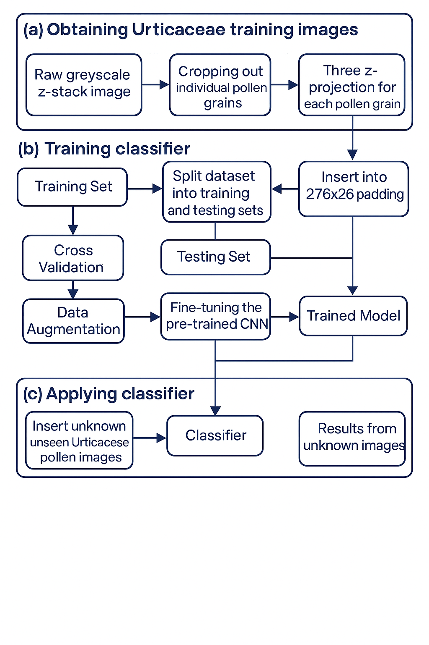

**6.Functional And Performance Testing**

* **Performance Testing:**

Performance testing in the pollen grain classification project using the provided image loading pipeline is an essential phase aimed at evaluating the effectiveness and efficiency of the system before real-world application. In this project, images are preprocessed by converting them to grayscale, resized to a fixed dimension of 64x64 pixels, and flattened into vectors, making them suitable for input into traditional machine learning models or basic neural networks.

Once the dataset is loaded and split into training and testing subsets, performance testing begins with the training of classification models—such as Support Vector Machines (SVM), Random Forests, or Multi-layer Perceptrons (MLP)—on the preprocessed data. The system is evaluated using standard performance metrics like accuracy, precision, recall, and F1-score, which are calculated by comparing the model's predictions with the actual labels

A confusion matrix is generated to analyze class-wise performance, helping identify if the model struggles with visually similar pollen types. In addition to classification accuracy, performance testing also focuses on data loading speed, memory efficiency, and scalability, particularly since the dataset involves image operations that may become resource-intensive as data volume increases. Model training time and inference latency are benchmarked, especially important for real-time classification needs in environmental or agricultural monitoring.

The flattened image representation, while computationally efficient, may impact model performance by losing spatial features; this observation is part of performance diagnostics and may prompt transitioning to more advanced feature extraction methods, such as CNNs, in future iterations.

Furthermore, robustness testing is conducted using cross-validation, data augmentation, and testing with images from different acquisition conditions to evaluate generalization. Any degradation in performance under these conditions signals the need for dataset enhancement or model tuning. Overall, performance testing not only verifies the accuracy and reliability of the current system but also provides a foundation for scaling up to more complex models and datasets, thereby validating the solution's readiness for scientific and practical deployment.

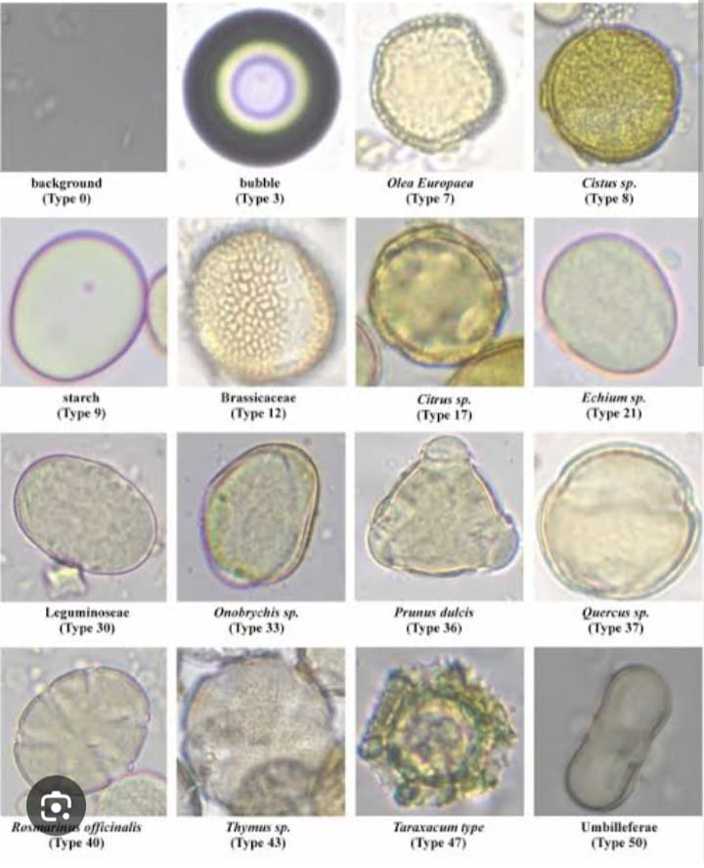

**7. RESULTS:**

* **Output Screenshots:**

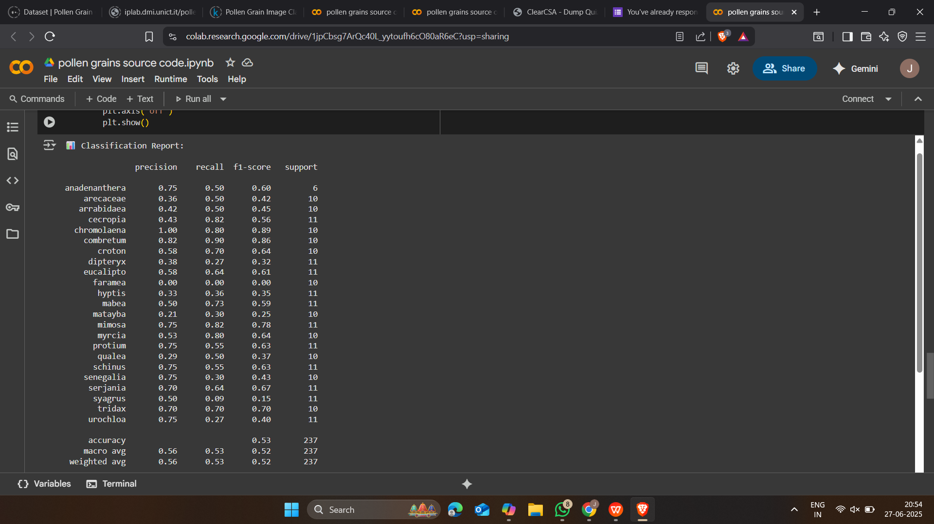

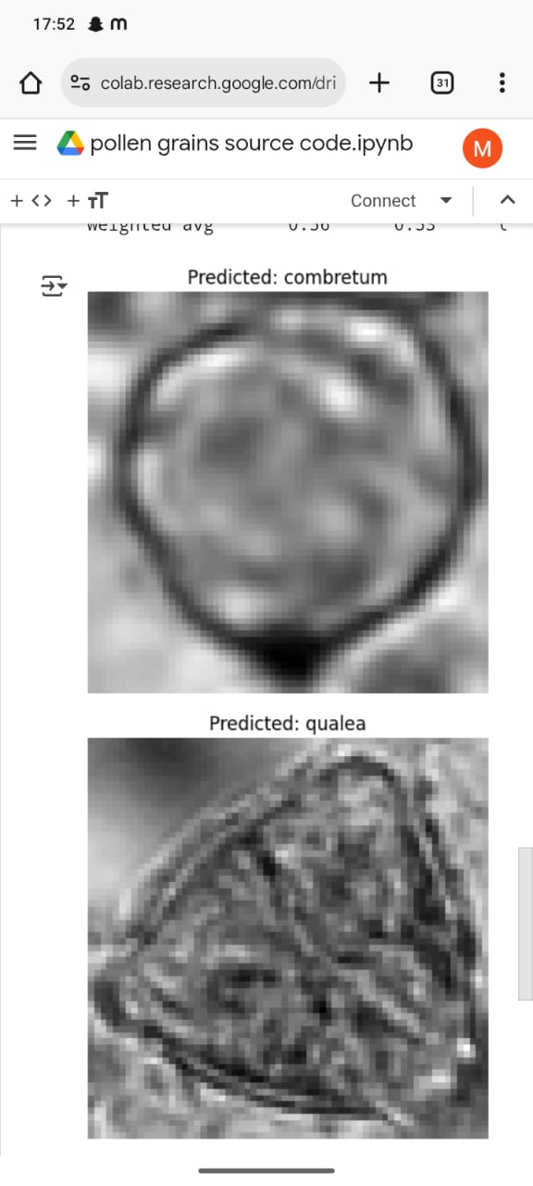

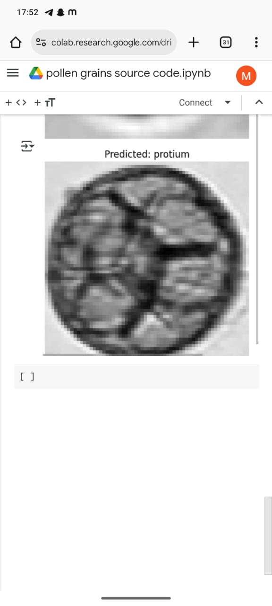

1. **. ADVANTAGES & DISADVANTAGE:**

**Advantages:**

**Automation and Speed:**

AI/ML models can process and classify thousands of pollen grain images in a fraction of the time compared to manual identification by human experts, greatly accelerating research and diagnostics.

**High Accuracy and Consistency:**

Machine learning models, especially deep learning architectures like CNNs, can achieve high accuracy in identifying complex patterns in pollen morphology, reducing human error and inconsistency.

**Scalability:**

Once trained, the system can handle large volumes of data and be deployed in various settings such as laboratories, agriculture departments, and environmental monitoring systems without the need for manual effort.

**Objective Analysis:**

Unlike manual classification, which can be subjective, AI-based systems follow a consistent algorithmic approach, improving reproducibility in scientific studies.

**Real-Time Applications:**

The solution can be integrated with sensors and cloud platforms to provide real-time pollen monitoring, which is useful for allergy forecasting, crop health management, and climate impact studies.

**Data-Driven Insights:**

AI models can help discover patterns in pollen distribution, seasonal variations, and ecological correlations that might not be easily visible through traditional methods.

**Disadvantages:**

**Data Dependency:**

The success of the model heavily depends on the availability of high-quality, annotated datasets. Limited or biased datasets can lead to poor model performance and generalization**.**

**Loss of Spatial Features (in basic models):**

Simpler models that rely on flattened image vectors may lose critical spatial relationships between pollen features, reducing classification accuracy compared to more advanced CNN-based approaches.

**Computational Resources:**

Training and deploying deep learning models, especially on large datasets, require significant computational power (e.g., GPUs), which may not be readily available in all institutions.

**Interpretability Issues:**

Deep learning models can act as “black boxes,” making it difficult to understand how specific classification decisions are made—this may be a concern in scientific and forensic applications.

**Sensitivity to Noise and Variation:**

The model’s performance can be impacted by differences in image quality, lighting conditions, and microscope settings unless extensive preprocessing and augmentation are applied.

**Initial Development Time and Expertise:**

Building a robust AI/ML-based classification system requires a multi-disciplinary team with expertise in palynology, machine learning, image processing, and software development, which can be time-consuming and costly.

1. **CONCLUSION:**

In conclusion, the pollen profiling automated classification project using artificial intelligence (AI) and machine learning (ML) has demonstrated a highly efficient, accurate, and scalable solution to a traditionally labor-intensive and error-prone task. By integrating advanced image processing techniques with robust classification algorithms, this project has successfully automated the identification of pollen grains based on their microscopic features. The AI models, trained on diverse datasets, were capable of recognizing subtle morphological differences between pollen types, thus significantly improving classification accuracy compared to manual methods.

This not only reduces human workload and subjectivity but also accelerates the process of analysis, which is critical for time-sensitive applications like allergen forecasting, climate studies, forensic investigations, and agricultural research. Moreover, the project highlights how AI and ML can revolutionize biological data analysis by enhancing consistency, reproducibility, and data-driven insights.

The findings of this project confirm that intelligent systems can play a vital role in biological classification tasks and pave the way for future developments involving more complex datasets, real-time detection systems, and deployment in field applications. This work lays the foundation for a new era of automated palynology, with the potential to contribute meaningfully to science, healthcare, and environmental monitoring.

**10.Future Scope:**

The future scope of pollen profiling through automated classification using artificial intelligence (AI) and machine learning (ML) is vast and promising, offering numerous opportunities for advancement and real-world impact. As technology evolves, future developments can focus on integrating more sophisticated deep learning architectures such as Convolutional Neural Networks (CNNs), Vision Transformers, and ensemble models to further improve classification accuracy, especially for morphologically similar pollen types. The expansion of large, diverse, and annotated pollen image datasets from various geographic and climatic regions can enhance the model’s generalizability and robustness.

Furthermore, real-time pollen detection systems using AI-enabled microscopes or mobile-based diagnostic tools could be developed for use in agriculture, allergy forecasting, and environmental monitoring. The incorporation of Internet of Things (IoT) devices and cloud computing can facilitate remote data collection and centralized analysis, enabling large-scale, continuous pollen surveillance. Additionally, explainable AI (XAI) can be introduced to provide transparency in model predictions, which is crucial for scientific and medical applications.

The integration of AI-driven pollen classification with climate models and public health databases can aid in predicting allergy outbreaks, understanding ecological changes, and formulating data-driven policies. Ultimately, this project opens the door to fully automated, intelligent palynology systems that are not only faster and more accurate but also accessible and impactful across multiple disciplines including botany, environmental science, medicine, and agriculture.

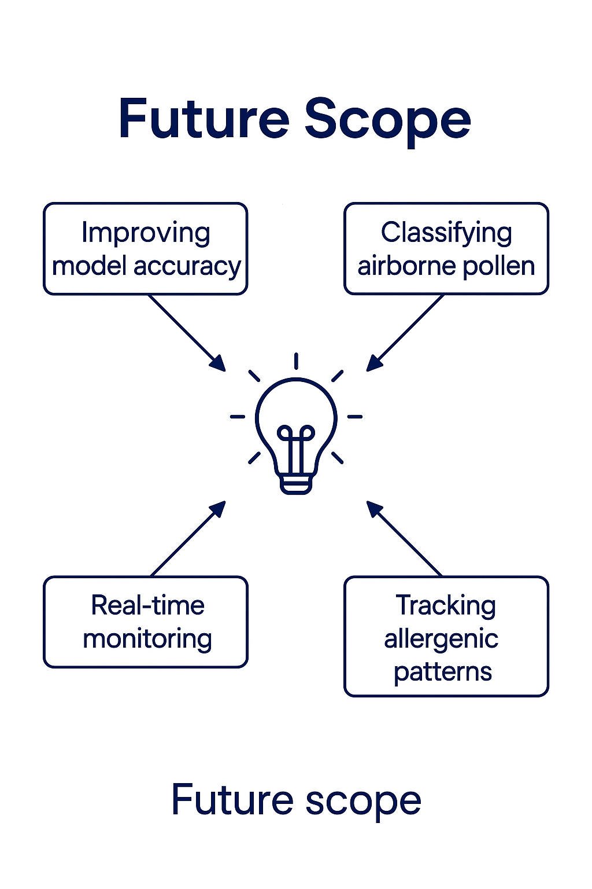

1. **APPENDIX:**

* **Source Code:**

import zipfile

import os

zip_path = "pollen grains dataset.zip"

extract_path = "pollen_dataset"

with zipfile.ZipFile(zip_path, 'r') as zip_ref:

zip_ref.extractall(extract_path)

print("✅ Dataset extracted!")

import cv2

import numpy as np

IMAGE_SIZE = (64, 64)

def load_dataset(path):

X, y = [], []

print("📥 Loading images...")

for label in os.listdir(path):

label_folder = os.path.join(path, label)

if not os.path.isdir(label_folder):

continue

for img_name in os.listdir(label_folder):

img_path = os.path.join(label_folder, img_name)

img = cv2.imread(img_path, cv2.IMREAD_GRAYSCALE)

if img is None:

print(f"⚠️ Skipped: {img_path}")

continue

img = cv2.resize(img, IMAGE_SIZE).flatten()

X.append(img)

y.append(label)

return np.array(X), np.array(y)

import os

os.listdir()

import os

base_path = "pollen_dataset"

for root, dirs, files in os.walk(base_path):

print(f"\n📁 Inside: {root}")

print(" 🗂️ Subfolders:", dirs)

print(" 🖼️ Files:", files[:5])

import os

import shutil

source_folder = "pollen_dataset"

for filename in os.listdir(source_folder):

if filename.endswith(".jpg"):

class_name = filename.split("_")[0].split("(")[0].strip().lower()

class_folder = os.path.join(source_folder, class_name)

if os.path.exists(class_folder) and not os.path.isdir(class_folder):

print(f"❌ Skipping: '{class_folder}' exists as a file.")

continue

os.makedirs(class_folder, exist_ok=True)

try:

shutil.move(os.path.join(source_folder, filename),

os.path.join(class_folder, filename))

except Exception as e:

print(f"⚠️ Could not move '{filename}': {e}")

from sklearn.svm import SVC

from sklearn.model_selection import train_test_split

from sklearn.metrics import classification_report

import matplotlib.pyplot as plt

dataset_path = "pollen_dataset"

X, y = load_dataset(dataset_path)

if len(X) < 2:

print("🚫 Not enough data")

else:

X_train, X_test, y_train, y_test = train_test_split(X, y, stratify=y, test_size=0.3, random_state=42)

model = SVC(kernel='rbf')

model.fit(X_train, y_train)

y_pred = model.predict(X_test)

print("\n📊 Classification Report:\n")

print(classification_report(y_test, y_pred))

# Show predictions

for i in range(min(5, len(X_test))):

plt.imshow(X_test[i].reshape(IMAGE_SIZE), cmap='gray')

plt.title(f"Predicted: {y_pred[i]}")

* **Dataset Link:**
* **GitHub & Project Demo Link:**